In the Grand List program on the ‘Reports’ menu you can run a ‘State Treasurer’s Report’. This report will show you all the parcels that had a change to their tax amounts or an HS 122 Late Filer Penalty applied. This report is very helpful when you are trying to reconcile your data at the end of the year.

To run this report you must enter the appropriate ‘As Billed Grand List’ and go to the ‘Reports’ menu. Select
‘M State Treasurers Report’.

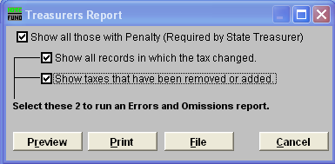

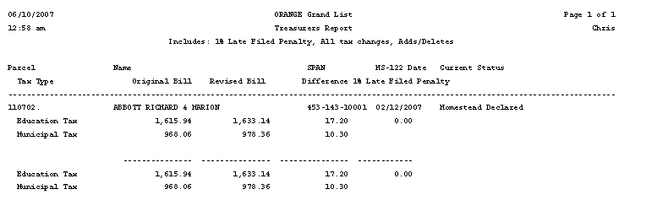

Shows the change in the parcels taxes.

Total of all adjustments made. Note that if a parcel has been charged for a 1% penalty that amount will be reflected in the ‘Difference’ column.

